**Your Endoscopy procedure**

**In light of the current COVID-19 pandemic, extra measures have been put into place to minimise risk to both patients and staff. Please note the following on the day of your colonoscopy/flexible sigmoidoscopy procedure:**

* **Please arrive at the St Mark’s Hospital Patient Entrance (as indicated in the map below).**

Before you can enter the hospital building, you will be asked if you have/or have had any COVID symptoms within the last 14 Days; and you will have your temperature checked.

* If there is no member of staff present at the St Marks Entrance to check your temperature, **please ring the Bowel Cancer Screening Department on 020 8869 3543 to confirm your arrival.** If you do not have a mobile phone then please ask the St Mark’s Receptionist to contact us on **extension 3543** to confirm your arrival. A member of the team will then meet you at the entrance and carry out the necessary checks.
* We regret that at this time we cannot have family members/friends attend the appointment with you. If you are being dropped off, **please ensure that your escort either waits for you in their car, or outside the St Mark’s Patient Entrance**.
* Your colonoscopy procedure will be held in the endoscopy department, based on Level 3 of St Marks Hospital.
* **The BLUE line on the floor from the St. Mark’s main entrance will guide you to Endoscopy reception door.**
* Once you reach the endoscopy door, kindly press the buzzer on the right hand side.
* An admission nurse will meet you at the endoscopy door and escort you for further checks.
* **You will be asked to apply alcohol gel to your hands and wear a surgical mask throughout your procedure**.

N.B Surgical masks will be worn at all times by screening centre staff you come into contact with.

**Please DO NOT attend your appointment if you are currently experiencing any COVID symptoms, or have had symptoms within the last 14 days:-**

* **Your appointment will need to be deferred for at least 14 days from the time your symptoms started. Please call us on 020 8869 3543 for further advice, and to arrange an alternative date.**

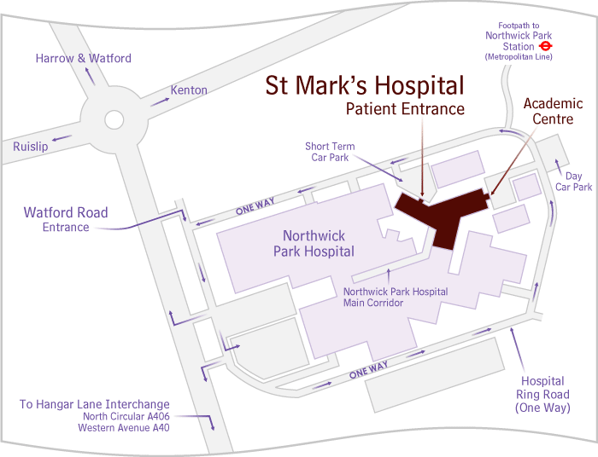

**How to Get Here**

**Northwick Park and St Mark’s Hospitals are situated on one site along the Watford Road in Harrow, near the Northwick Park Roundabout and next to the Play Golf Northwick Park golf club.**

For full travel and visitor information, including maps and car parking information, please visit the hospital website at:-

<http://www.lnwh.nhs.uk/patients-visitors/locations-of-our-services/northwick-park-and-st-marks-hospitals/>

**However, during this current time, it is recommended that patients avoid public transport wherever possible.**

**By car**



Please note that the site must be approached from the roundabout to the north; no right-turns from the south are permitted. Follow the Northwick Park ring road signs for St. Mark's, which has its own Car Park (Car Park 4) and entrance where we ask you to observe the speed limit of 10mph.

**Parking is available throughout the hospital grounds but the nearest Car Park is at the St Mark’s Hospital Entrance (Car Park 4).**

**Please note that you can expect to be here for approximately 3-4hours, therefore parking charges start at £6.60* for up to five hours** (*price correct @ 1st April 2020 but subject to change*)**. There are also a limited number of disabled spaces which are free to permit holders.**

*Note: for a limited time during the COVID-19 pandemic, car parking is FREE. However, please double check the payment machines on arrival as this is subject to change. Please also allow plenty of time to arrive before your appointment, as spaces in Car Park 4 may be limited, and you may have to park in one of the other car parks on the hospital site.

**Tube and rail links**



Northwick Park on the Metropolitan Line is the nearest Tube station to the hospitals, five minutes’ walk away. Kenton station, for Bakerloo and London Over ground services, is about a 10-15 minute walk away.

**Buses**



**Several buses stop outside the hospital including the H9, H10, H14, 186 & 223. Northwick Park tube station on the Metropolitan Line is a five minute walk away from the hospital, whilst Kenton Station which is on the Bakerloo and London Over ground is a 10-15 minute walk to the hospital.**

Bus routes 186, 223, H9, H10 and H14 enter the grounds of the hospital, and route 182 stops a short distance away on Watford Road. Bus routes 114 and 183 stop on Kenton Road, about a 10 minute walk from the hospitals.

Low floor, wheelchair accessible buses run on all these routes. Please note that the H9 and H10 bus routes now terminate outside St Mark’s Hospital, making it more convenient for patients.

**Further travel information can be obtained from** [**www.tfl.gov.uk**](http://www.tfl.gov.uk) **Tel: 020 7222 1234**